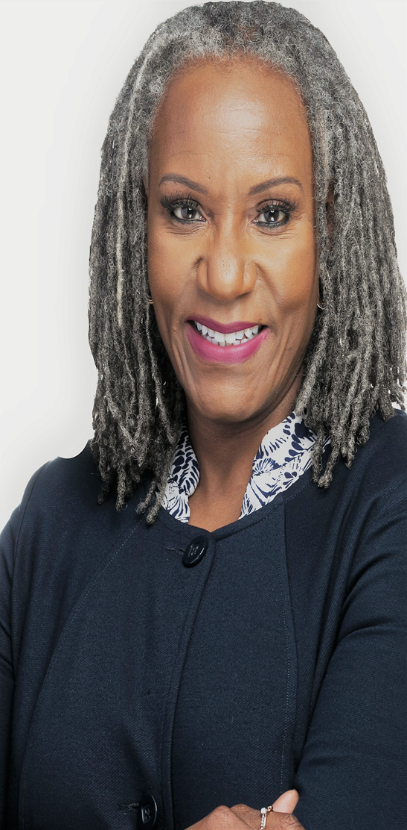 | Name: Phyllis T. Turner-Brim
Company Name:
Starbucks Coffee Company
Current or Most Recent Role:
Vice President, Assistant General Counsel
Are You The Top Legal Officer – GC/CLO?
No
To whom do you report (Title):
EVP, General Counsel and Secretary
 | Education: Juris Doctor, University of Cincinnati; B.S. Chemical Engineering, Illinois Institute of Technology (honors)
 | Law School Graduation Date: 1993
GC Sponsors:  (GCs or former GCs who recommends you as a Ready Now Fortune 1000 GC)  David Kris, GC Intellectual Ventures Management (former)  Janis Harwell, GC Intermec Technologies Corporation (former)  Carol Bernstein, GC Cabot Microelectronics Corporation  Wanji Walcott, GC Paypal | Company Revenue and Market Cap: $23B/$83B  Public? Yes  Primary Area(s) of Practice/Experience (explain):  Intellectual property, technology and ip transactions, commercial, ip public policy, marketing, advertising, strategy, m&a due diligence
Any Geographical Preferences or Restrictions?  Will consider any, preference for South, Southeast, Southwest, Midwest, West Coast. | Law Firm Experience (firms, years practice areas):  McAndrews, Held & Malloy Ltd; intellectual property, 1993-1997
Prior In-House Titles: VP Chief IP Counsel; Director RFID Licensing and Strategy; Asst. GC Intellectual Property; Associate GC, Intellectual Property | Industry Experience: Specialty chemicals, consumer products, auto-identification/RFID, mobile computing, retail, ip monetization, semi-conductors.
Contact Information:  phyllis.turnerbrim@gmail.com  479-531-7114  13020 63rd Ave SE, Snohomish WA 98296 | Size of the Largest Team Managed (explain):  59 (3 managing counsel (direct reports), 30 attorneys, balance paralegal and administrative personnel. Current team 24 (3 managing counsel direct reports, 9 attorneys, 12 paralegals).
Explain level of Corporate Governance and Corporate Board Room Experience: Regular participant, presenter and advisor in private company board meetings. Starbucks audit committee on the topic of privacy (2017-2018). Preparing board books (support) | In which of these critical areas do you have experience -- M&A, Securities, Corporate Governance, Finance, Litigation Management, Compliance, Regulatory and Enterprise Risk Assessment? Please explain.  Litigation management – responsibility for managing Starbucks intellectual property litigation, including selecting counsel and developing strategy. Similar role with past employers.  Compliance – Responsible for Starbucks privacy compliance function, with emphasis on preparing and executing plan for GDPR compliance. Leading legal team that advises on cybersecurity and privacy.  Enterprise Risk Assessment – Led privacy risk assessments, part of enterprise risk committee with focus on privacy, cybersecurity and food safety.  Corporate Governance: Regular participant, presenter and advisor in private company board meetings. Starbucks audit committee on the topic of privacy. Second chair to GC in relation to Board management.
Experience with Public Company Securities Issues: Reviewer of filings, particularly in relation to ip issues and risk factors. | International Experience:  Led global ip practices at four multinational, publicly traded corporations. Negotiated licenses with international counter parties, including for chemical plants in China. Global responsibility for legal advice relating to privacy, cybersecurity and technology transactions.
Summary of Experience/Bio: (300 words or less)
Accomplished executive and C-suite advisor with over 25 years of legal experience, 20 plus years in-house. Led or served key roles in developing business and intellectual property strategies, evaluating and developing investment theses, structuring and executing public policy initiatives, designing and implementing mission critical business processes, structuring joint development initiatives and intellectual property transactions, building effective licensing programs. Effective, highly emotionally intelligent leader of high performing teams. 17 years of leadership experience with teams ranging from small teams of a few expert attorneys to a large organization of sixty professionals comprised of three Chief Counsels, thirty attorneys, and twenty paralegals. Demonstrated expertise in organization and process design to achieve business success. Competencies in data privacy, cybersecurity, marketing and advertising. Key architect of organizational restructuring to align business objectives and realize significant costs savings. Experienced in a wide range of technologies and industries, including high tech, specialty chemicals, consumer products, international and domestic licensing, retail, medical devices and distribution.

