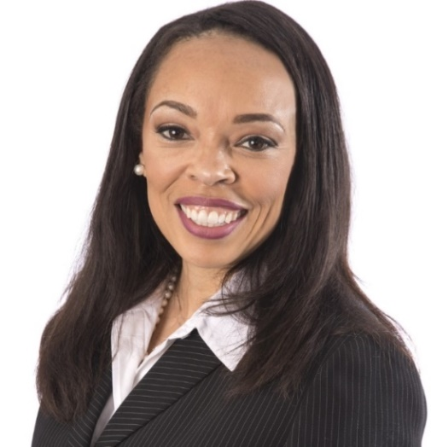 | Name: Monica Howard Douglas
 | Company Name: The Coca-Cola Company
 | Current or Most Recent Role: General Counsel, North America
 | Are You The Top Legal Officer – GC/CLO? No
To whom do you report (Title): General Counsel

Education: University of Michigan; Stanford Law School

Law School Graduation Date: July, 1997
GC Sponsors: Lesley Turner | Company Revenue and Market Cap:  Market Cap – 200 billion, Revenue – 35 billion  Public? Yes
Any Geographical Preferences or Restrictions? Preference is Georgia, but I can be flexible. | Primary Area(s) of Practice/Experience (explain):  Generalist, litigation, M&A, IP, Antitrust, marketing, commercial and compliance.
Prior In-House Titles: Legal Director, Africa; Marketing and Sports Counsel, Senior Managing Counsel, Supply Chain and Logistics | Law Firm Experience (firms, years practice areas):  Troutman Sanders 1998-2002
Industry Experience: CPG and finance | Size of the Largest Team Managed (explain):  I currently manage a team of 35 attorneys and 22 paralegals.
Contact Information:  Monica_howard@yahoo.com  678-361-6908  1100 Ivey Ridge Place  Mableton, Ga 30126 | In which of these critical areas do you have experience -- M&A, Securities, Corporate Governance, Finance, Litigation Management, Compliance, Regulatory and Enterprise Risk Assessment? Please explain. All other than securities. In my various roles as a generalist, I manage a team that has manages each of these areas of responsibility. While in South Africa, I had primary responsibility for each of these areas.
Explain level of Corporate Governance and Corporate Board Room Experience:
I serve on the Ethics Committee for the Company and have to report to the audit committee on governance issues.
Experience with Public Company Securities Issues:  I liaise with our security lawyers on Company securities matters. | International Experience:  I managed the legal division and supported the business units in Southern, Central and East Africa for 4 years from 2013-2017.  I currently support Canada business team and oversee compliance globally.
Summary of Experience/Bio: (300 words or less)
After earning her B.A. from the University of Michigan and her J.D. from Stanford Law School, Monica Howard Douglas began her legal career as a judicial law clerk for Damon J Keith on the Sixth Circuit Court of Appeals of the United States. She later joined the law firm of Troutman Sanders where she was an associate in the corporate practice group and then subsequently gained in-house experience as a generalist at the Atlanta based Equifax Corporation. In 2004, Monica joined The Coca- Cola Company where she has consistently been promoted into roles of increasing size, scope and complexity. Her career path reflects her experience as a key business partner, an effective compliance officer and an inspirational legal manager. Throughout her career, she has helped lead transformational change by building diverse, high performing teams and establishing cultural norms of compliance and good business. Amongst other achievements, Monica has served as a key player in significant business transformations, implemented strong governance practices, managed acquisitions and mergers, advised Key Executives, Board Members and leveraged external stakeholders. She has developed a reputation as an innovative and trusted business partner who leads with consistent and aligned purpose which has served her well during her tenure in both developed and developing markets. In 2013, Monica moved to Johannesburg South Africa where she served as the Legal Director for the Southern and East Africa Business Unit that included 24 countries in Southern, East and Central Africa. It was there that Monica served on the executive business unit team, introduced a new governance model, restructured our bottling system, built relationships with regulators and managed through major tax and antitrust issues. After spending four years in South Africa, Monica returned to The Coca-Cola headquarters in Atlanta where she currently serves as the General Counsel of North America. In this role, Monica manages a large team of lawyers who support 4 business units, more than 250 brands, an aggressive innovation and acquisition strategy, and a complicated franchise bottling system with more than 50 independent bottling partners. She also serves the important role as a member of the Ethics and Compliance Committee that oversees the governance for the Company. Monica has participated in the Harvard Business School Executive Management Program and has received awards for her commitment to the community, including the 2019 Atlanta Business Chronicle In-House Diversity Champion.

