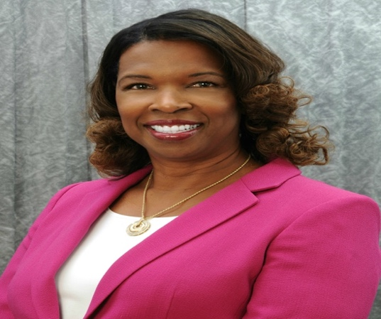 | Name: Michelle I. Ritter
 | Company Name: Westlake Chemicals Corporation (most recent employer)
 | Current or Most Recent Role: GC, Chemicals, Axiall Corporation, a Westlake Company
Are You The Top Legal Officer: No

To whom do you report (Title): Reported to the Senior Vice President, General Counsel, Chief Administrative Officer and Corporate Secretary
Company Revenue and Market Cap: Westlake Chemicals Corporation: Revenue 8.2 B Market Cap 15.2 B

Public? Yes
Education: JD, University of Pittsburgh, School of Law; MBA, University of Pittsburgh, Joseph M. Katz, Graduate School of Business; BS, Carnegie Mellon University (Administration and Management Science)  Law School Graduation Date: 1987 | GC Sponsors:  Timothy Mann, Jr. (former President and CEO of Axiall); Currently, Exec. VP , GC and Corporate Secretary of Louisiana-Pacific Corp.
Any Geographical Preferences or Restrictions? PA, FL, IL, NC, NY, OH, WI, NJ, MD, DC, VA; no restrictions | Primary Area(s) of Practice/Experience (explain):  Commercial transactions (drafted and negotiated numerous high-value contracts); regulatory (environmental, antitrust); trade compliance (lead internal counsel); legal responsibility for Chemicals IP portfolio; and supply chain (lead internal counsel). Provided day-to-day counsel to senior executives and their staffs. Member of Chemicals Leadership team.
Prior In-House Titles: Division General Counsel, Chemicals; Corporate Counsel; Senior Counsel, EHS (head of section); Senior Attorney; and Attorney | Law Firm Experience (firms, years practice areas):  Associate for 4 years at Thorp, Reed & Armstrong (now Clark Hill PLC) in Pittsburgh, PA. Practice areas were M&A, litigation, real estate and general corporate
Contact Information  Mrittercrawford17@gmail.com  412-389-2288; 604 Arden Drive, Monroeville PA., 15146 | Industry Experience: Industrial Chemicals Sector; Manufacturing; Coatings; Water Treatment  Size of the Largest Team Managed (explain):  7 (4 attorneys, 1 IP agent, 2 support staff)
Explain level of Corporate Governance and Corporate Board Room Experience:  Former secretary to the EHS committee, chaired by the former CEO and GC of PPG Industries. Counsel to the US Board members of Axiall’s Indian JV. Counsel to PPG’s Government Affairs committee on transportation matters. Supported Axiall’s CEO on corporate governance investor matters regarding Westlake’s acquisition of Axiall. Advised PPG’s corporate risk manager on certain corporate risks. Served as secretary to the PAC at Axiall. | Experience with Public Securities Issues:  Reported legal aspects of environmental reserves for SEC reports and contributed to and reviewed 10Q and 10K filings.  In which of these critical areas do you have experience -- M&A, Securities, Corporate Governance, Finance, Litigation Management, Compliance, Regulatory and Enterprise Risk Assessment? Please explain.  M&A: advised corporate teams on several M&A transactions as Chemicals counsel and EHS counsel. Participated on due diligence teams and in negotiations.  Securities and Corporate Governance (see prior info)  Finance: was lead internal counsel on financing for barges for the Chemicals business at Axiall. Worked with the corporate treasurer and purchasing team.  Litigation Management: responsible for the litigation budget at Axiall for the Chemicals Division. Worked with litigation team on a regular basis and participated in litigation review meetings.  Compliance/Regulatory: formerly in charge of the EHS legal function at PPG and lead trade compliance lawyer; counseled senior executives and staffs on antitrust compliance; advised on day-to-day compliance matters as GC for the Chemicals Division.  Risk Assessments: advised on enterprise, EHS, trade and supply chain assessments.
International Experience:
In-house legal responsibility for the creation and negotiation of a 50/50 Axiall JV in India. Provided ongoing legal counsel to the US Board members of the Indian JV. Lead lawyer for global EHS audits of international plants. Responsible for FCPA audits of Taiwan and Indian operations. Led to resolution a significant international trade compliance investigation as lead internal lawyer. Worked with senior executives on global crisis response team that managed a climate-caused situation in international locations as well as other matters.
Summary of Experience/Bio: (300 words or less) Michelle I. Ritter is a seasoned in-house corporate general counsel with significant experience addressing matters at the intersection of law and business. Most recently Michelle served as General Counsel, Chemicals, Axiall Corporation, a Westlake Company where she was a strategic business and legal advisor to senior executives and their teams.
Her move to Axiall followed 21 years with PPG, Industries, Inc. where she rose through the ranks to become Corporate Counsel in 2006, a title she held through 2012. She was a key legal liaison between PPG and Axiall during their $2 billion merger, becoming Axiall’s Division General Counsel, Chemicals in 2013.
In addition to her understanding of strategic legal/business partnering, Michelle has experience with risk management, crisis response, regulatory compliance, trade compliance, intellectual property, environmental, SEC disclosures, mergers and acquisitions, due diligence, corporate governance, litigation management, employment, supply chain and PAC matters.
Her lasting accomplishments include spearheading the development of a formal, global corporate trade compliance team and program; forging productive partnerships between the U.S. and Indian business teams of Axiall through the creation of a joint venture in India; leading to resolution a significant international trade compliance investigation; and championing the creation of a formal process governing confidentiality agreements to protect vital trade secrets. Michelle has drafted and negotiated numerous commercial transactions and led high performing and talented in-house and outside legal teams through settlements, investigations, audits, and negotiations involving many millions of dollars.
Michelle earned her B.S. in Administration and Management Science from Carnegie Mellon University and her M.B.A. and J.D. from the University of Pittsburgh. She began her law career as a summer associate, then associate, at Thorp Reed & Armstrong, now Clark Hill, LLC. Michelle has served on several nonprofit boards in the Pittsburgh area and enjoys traveling and attending professional tennis tournaments.

