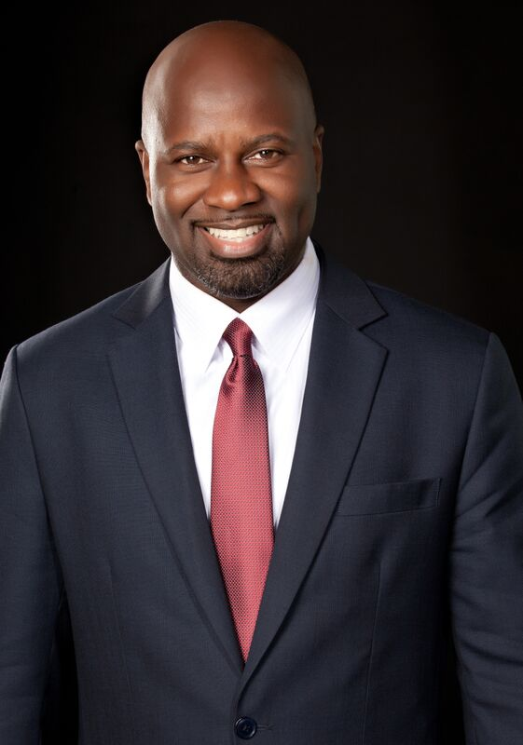 | Name: Ernest A. Tuckett
 | Company Name: AkzoNobel
Current or Most Recent Role:
General Counsel Americas (former)
 | Are You The Top Legal Officer – GC/CLO? No
To whom do you report (Title):
Global Legal Director
Education:  Georgetown University Law School  Georgetown University, BA Govt | Company Revenue and Market Cap:  Revenue - $20 Billion
Law School Graduation Date: 1995 | Public? Yes
GC Sponsors:  (GCs or former GCs who recommends you as a Ready Now Fortune 1000 GC)  Stacey Mobley, former GC, DuPont  Verona Dorch, GC, Peabody Energy  Marianne Niles, former GC Washington Wizards & Capitals  Sharon Barner, GC, Cummins | Primary Area(s) of Practice/Experience (explain):  Commercial Transactional – 2010-pres.  Litigation – 10 years at the law firm; in-house litigation management for 14 years  Labor & Employment – 35% of my time at the firm, in-house L&E counsel from 2006-2010  Compliance – Chief Compliance Officer for the Americas; counsel to Ethics & Compliance for 14 years
Any Geographical Preferences or Restrictions?  None | Law Firm Experience (firms, years practice areas):  Arent Fox 1995-2006, Washington, DC, Commercial Litigation and Employment Litigation
Prior In-House Titles:  General Counsel of DuPont Canada  Global Corporate Counsel, DuPont Crop Protection  Corporate Counsel – L&E, DuPont | Industry Experience:  Chemical Manufacturing, Agriculture, Paints & Coatings, Food Additives, Safety Consulting, Polymers, Plastics
Contact Information:  ernesttuckett@yahoo.com  240-354-7098; Chicago, IL | Size of the Largest Team Managed (explain): 20  (7 lawyers in Chicago, 4 lawyers in Brazil, 2 Compliance Officers, paralegals, secretaries and Legal Office Manager)
Explain level of Corporate Governance and Corporate Board Room Experience:  AkzoNobel- assisted global Corp Secretary in preparing materials for the Board on critical issues; created a global corporate governance procedure for managing local legal entities around the world; created a global module for training directors & officers and trained 75+ officers and directors. | In which of these critical areas do you have experience –  M&A, Securities, Corporate Governance, Finance, Litigation Management, Compliance, Regulatory and Enterprise Risk Assessment? Please explain.  M&A multiple deals from 2010-2018; Corporate Secretary of AkzoNobel in North America and DuPont Canada; Litigator by background and managed in-house litigation; legal counsel to many heavily regulated businesses (e.g., agriculture); Responsible for Enterprise Risk Assessments in the Americas for AkzoNobel
Experience with Public Company Securities Issues:  Attending corporate governance intensive CLEs; active in NACD; 1-on-1 tutorials from big law securities partner | International Experience:  Global commercial and IP transactions and M&A deals as commercial counsel to DuPont Crop Protection  Responsible for all legal, compliance and corporate governance in North & South America  Led a legal team in Canada
Summary of Experience/Bio: (300 words or less)

Most recently served as Chief Legal Officer, Corporate Secretary and Chief Compliance Officer for the Americas region for AkzoNobel, a global chemical, paint and coatings company. I managed the legal teams in North America and South America. I was a member of the North American executive leadership team tasked with managing company operations. I created a governance model for local legal entities in North America that the global Corporate Secretary adopted and rolled out to all regions of the company globally. I was M&A lead in the Americas for AkzoNobel. My team supported all 12 business units of the company and all corporate functions.

Prior to AkzoNobel, I served for almost 3 years as General Counsel of DuPont Canada. I was the first non-Canadian the company assigned to take this role. I was a member of the executive leadership team in the country, and was responsible for corporate governance and compliance, as well as legal. My team supported all 13 business units and all corporate functions. I led M&A in the country including on 2 major global corporate splits – on sold to private equity and the other a public spinoff.
At DuPont before Canada, I was global commercial lawyer for DuPont Crop Protection, a multi-billion dollar business, and I served on the leadership team led by the BU President. I worked on multiple M&A deals as well in this role. Before that I was L&E counsel for DuPont in the US for 4 years. I began my career as a Litigator with Arent Fox where I spent 10+ years and tried 7 cases to verdict, and litigated hundreds of others, the vast majority to positive resolutions for my clients.

