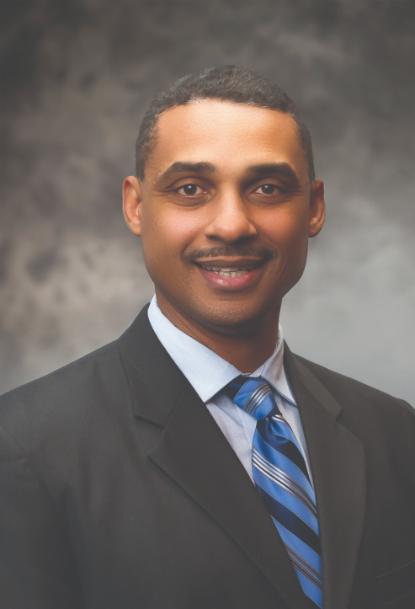 | Name: Damon T. Jones
 | Company Name: Washington Nationals Baseball Club and related affiliates
Current or Most Recent Role:
Senior Vice President & General Counsel,
Baseball & Business Operations
Are You The Top Legal Officer – GC/CLO?
Yes XX No
To whom do you report (Title):
Board of Directors/Principal Owners

Education: The Wharton School of Business (AMP-2018); Harvard Law School (JD-1998); University of California, Santa Barbara (BA-1993) | Company Revenue and Market Cap: Market Cap:  Market Cap: ~$1.8 Billion; Revenue: ~$336 Million
Law School Graduation Date: June 1998 | Public?  Yes No: XX
GC Sponsors:  (GCs or former GCs who recommends you as a Ready Now Fortune 1000 GC)  Dane Butswinkas (former General Counsel, Tesla; former Managing Partner, Williams & Connolly LLP) | Primary Area(s) of Practice/Experience (explain):  Business Transactions, Litigation Management, Intellectual Property, Employment & Labor, Insurance/Risk Management, Corporate Governance
Any Geographical Preferences or Restrictions?  No restrictions. CA, DC, NY preference. | Law Firm Experience (firms, years practice areas):  Williams & Connolly LLP (2002-07): Litigation - Civil and Criminal; Transactional - Media, Sports, and Entertainment.  Greenberg Glusker (1998-99): Litigation.
Prior In-House Titles:  Senior Vice President & General Counsel; Vice President & General Counsel; Vice President & Club Counsel | Industry Experience:  Sports, Media, Entertainment, Technology, Hospitality
Contact Information:  damon_jones@post.harvard.edu  202-465-5931  10900 Roundtable Ct., N. Bethesda MD 20852 | Size of the Largest Team Managed (explain):  9 (Combined reports from Legal Department and Human Resources Department)
Explain level of Corporate Governance and Corporate Board Room Experience:  Extensive experience in the following areas of Corporate Governance: Internal Controls, Risk Management, Governance Documents, Corporate Strategy, Corporate Officer Appointments, Audits, etc. Served for 9 years as Governance Chair and Secretary of affiliated non-profit with a high level, 21-member board. | In which of these critical areas do you have experience -- M&A, Securities, Corporate Governance, Finance, Litigation Management, Compliance, Regulatory and Enterprise Risk Assessment? Please explain.  I have experience in the following areas:  Corporate Governance, Litigation Management, Compliance, and Regulatory and Enterprise Risk Assessment.
Experience with Public Company Securities Issues:  Some litigation experience at Williams & Connolly representing public companies. High-level business training at The Wharton School | International Experience:  Heavy involvement in business operations in Latin America, including FCPA compliance, litigations, investigations, and business transactions
Summary of Experience/Bio: (300 words or less)
12 years as head of Legal Department of a mid-sized company with a global brand and a dynamic, public-facing business. Work closely with the Board on corporate governance, internal controls, risk management, and corporate strategy and have extensive experience making Board presentations. Also a member of the Senior Executive Strategy Team, working across 17 departments on business and legal strategy, deal negotiation, dispute prevention and resolution, and internal governance issues. Extensive in-house experience includes handling corporate transactions, managing domestic and international litigations and arbitrations, managing a high-profile intellectual property portfolio, handling employment and labor matters, handling internal and government investigations, providing legal and business advice regarding the use of new technologies, working closely with state government stakeholders, and serving as a key business partner to drive critical revenue generation activities. Also have extensive experience serving as General Counsel, Board Member, Secretary, and Governance Chair of the Board of an affiliated non-profit overseen by a deep and talented board. Practiced for 5.5 years at Williams & Connolly in Washington, DC, representing large public companies and prominent law firms in connection with complex civil litigation matters and grand jury investigations. Practice also included transactional work for sports and media celebrities. Clerked for current Chief Judge of the United States Court of Appeals for the Fourth Circuit.

