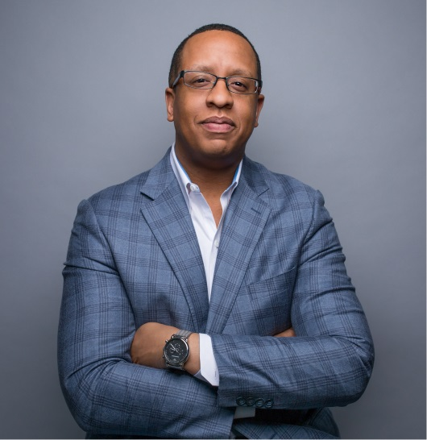 | Name: Damian W. Wilmot
 | Company Name: Vertex Pharmaceuticals Incorporated
Current or Most Recent Role:
Senior Vice President, Chief Risk & Compliance Officer
 | Are You The Top Legal Officer – GC/CLO? No X
To whom do you report (Title):
Executive Vice President, Chief Legal and Administrative Officer
Education:  Trinity College, Hartford, CT; Suffolk University Law School, Boston, MA | Company Revenue and Market Cap:  Revenue: $3.04B (2018); Market Cap: 43.3B
Law School Graduation Date: 2000 | Public? Yes
GC Sponsors:  (GCs or former GCs who recommends you as a Ready Now Fortune 1000 GC)  Al Parker (484) 343-4595  Mark Roelig (413) 627-9517 | Primary Area(s) of Practice/Experience (explain):  Litigation, securities, enterprise risk management, crisis management, employment, corporate governance, corporate compliance, pharmaceutical quality assurance (e.g,. GxP compliance)
Any Geographical Preferences or Restrictions?  None | Law Firm Experience (firms, years practice areas):  Goodwin LLP, Litigation Partner (2010-2014), Associate (2006-2010); Seyfarth Shaw, Associate (2001-2004)
Prior In-House Titles:  - Senior Vice President, Chief Risk and Compliance Officer (Oct. 2017 – Present)  - Vice President & Associate General Counsel – Chief Litigation Counsel (Jul. 2015 – Oct. 2017)  - Interim Head of Human Resources (Jan. 2017 – Aug. 2017)  - Interim Chief Compliance Officer (Aug. 2015 – Dec. 2015)  - Assistant General Counsel, Legal Affairs (2014 – 2015) | Industry Experience:  Vertex Pharmaceuticals Incorporated (2017-present); Sunovion Pharmaceuticals Inc. (2014-2015)
Contact Information:  dwilmot01@gmail.com  (617) 821-6682  4 Cunningham Lane, Milton, MA, 02186 | Size of the Largest Team Managed (explain):  100+. Manage global team located in Boston (Corporate HQ), London (International HQ), San Diego, Toronto, Sao Paulo, Paris, and Munich. Team consists of Legal, Compliance and Quality Assurance professionals.
Explain level of Corporate Governance and Corporate Board Room Experience:  HarborOne Bank: I serve as a director of this public company.  Vertex: Regularly attend meetings of and advise Board of Directors and Audit Committee on various subjects, including risk mitigation strategies, corporate governance, litigation, regulatory, compliance and investigatory matters.  Sunovion: Advised Boards of Directors of parent entity in Japan and US subsidiary on various legal, compliance and data privacy matters.  Goodwin Procter: Conducted investigations on behalf of and advised several public and private corporate boards on various legal matters (e.g., compliance, employment discrimination, executive misconduct). | In which of these critical areas do you have experience -- M&A, Securities, Corporate Governance, Finance, Litigation Management, Compliance, Regulatory and Enterprise Risk Assessment? Please explain.  Securities: Prosecuted securities violations as an Assistant US Attorney; litigated and lead securities matters as a Partner at Goodwin Procter; manage securities matters as in-house counsel  Litigation Management: Oversee all litigation for Sunovion and Vertex globally.  Corporate Governance: Advise senior management on matters of corporate governance  Compliance, Regulatory: Responsible for leading and managing Global Compliance (Office of Business Integrity & Ethics) and Quality Assurance organizations globally.  Enterprise Risk Assessment: Lead company’s Enterprise Risk Management (ERM) program globally and chair the ERM Committee.
Experience with Public Company Securities Issues:  Advised and defended public companies on securities related matters and litigation as both in-house and outside counsel. | International Experience:  Manage global team; advised and defended companies on various legal matters and litigation (e.g.,FCPA, employment, tax) as both in-house and outside counsel in EU, Asia, South America, Australia
Name: Damian W. Wilmot
Summary of Experience/Bio: (300 words or less)
Responsible for leading and managing Global Compliance (Office of Business Integrity & Ethics), Global Litigation & Enterprise Risk Management, and Quality Assurance organizations for a global, publicly-traded biotechnology company committed to the discovery and development of breakthrough small molecule drugs for serious diseases. Trusted legal advisor to senior management, board of directors and Audit Committee on various subjects, including risk mitigation strategies, corporate governance, litigation, GxP, data privacy and security, regulatory, compliance and investigatory matters. Lead company’s Enterprise Risk Management (ERM) program. Chair the ERM Committee and the Business Integrity & Ethics Committee. Also a member of various leadership committees, including the company’s Leadership Roundtable (the CEO and the company’s most senior executives), the Legal and Compliance Leadership Team and several steering and special project committees.
Before taking on current role in 2017, was the chief litigation counsel and also served as the company’s interim head of Compliance and interim head of Human Resources.
Previous professional experience includes serving as the chief litigation counsel for Sunovion Pharmaceuticals Inc., and as a litigation partner with Goodwin Procter LLP. Previously was an Assistant United States Attorney in the District of Massachusetts and worked as a judicial law clerk on the State of Connecticut Supreme Court.
Served on the boards and advisory committees of numerous nonprofit, civic, and for-profit organizations, including the Massachusetts Judicial Nominating Commission (by gubernatorial appointment), the John F. Kennedy Library Foundation, HarborOne Bank and the Boys and Girls Club of Boston. In 2010, recognized by the Boston Business Journal as one of Boston’s outstanding business leaders under the age of 40. Honored as one of Boston’s most influential people of color in healthcare and life sciences.

