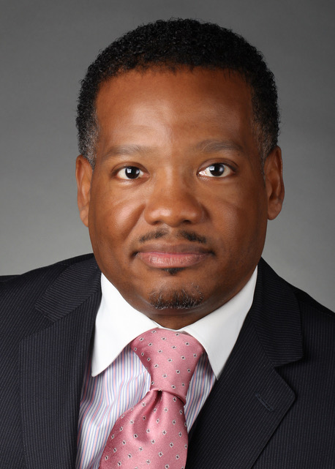 | Name: CHARLES J. CAREY
 | Company Name: SATCOM DIRECT, INC.
 | Current or Most Recent Role: DEPUTY GENERAL COUNSEL
Are You The Top Legal Officer – GC/CLO?
Yes No X
 | To whom do you report (Title): GENERAL COUNSEL
Education:  George Washington School of Law (LLM) Expected (2020)  The Catholic University of America, Columbus School of Law JD (2004)  Coppin State University, Computer Science/Mathematics BS (1999) | Company Revenue and Market Cap: Private Held Company; information not disclosed to public. Company holds 70% of the addressable market within its industry
Law School Graduation Date: 2004 | Public?  Yes No X
GC Sponsors:  Ann Davidson, SVP, General Counsel and Corporate Secretary, L-3 Technologies Corporation | Primary Area(s) of Practice/Experience (explain):  US Federal Government Contracting and global public sector (state, local, federal and international); Compliance, Regulatory, telecommunications
Any Geographical Preferences or Restrictions?  Mid-Atlantic | Law Firm Experience (firms, years practice areas):  None
Prior In-House Titles:  Vice President and General Counsel, Assistant General Counsel, Vice President and Associate General Counsel and Senior Corporate Counsel | Industry Experience:  Aerospace and Defense, Professional Consulting, Information Technology, Aviation Technology, Satellite and Telecommunications
Contact Information: (Email, Phone Number, Address)  charlesjcarey@gmail.com,  703-723-0341,  44370 Boxford Terrace Ashburn, Virginia 20147 | Size of the Largest Team Managed (explain):  100 professionals (Ethics & Compliance, Trade Compliance, Environmental Health & Safety, Industrial Security) as part of my responsibility as Vice President and General Counsel for $1.3Billion Business Segment
Explain level of Corporate Governance and Corporate Board Room Experience: Experience managing board related functions for multiple companies as board secretary. | In which of these critical areas do you have experience –  Extensive experience for a number of public, multinational companies in the area M&A, Litigation Management, Compliance (Trade, Ethics, Environmental, Health and Safety, Industrial security) and developing enterprise risk assessments and implantation.
Experience with Public Company Securities Issues: limited experience | International Experience:  Yes, Afghanistan, Bahrain, UAE, Canada, Australia and United Kingdom
Name: CHARLES J. CAREY
Summary of Experience/Bio: (300 words or less)

Mr. Carey is a skilled advocate, negotiator and business partner with 15 years of experience specializing in-house legal risk management and compliance representing numerous products and services (from business consulting to defense products, services, worldwide information technology, satellite and telecommunications) spanning across 100+ countries accounting for billions in commercial and public sector contracting dollars. Experience managing complex legal matters with several multinational corporations with a reputation as a trusted legal advisor known for developing and spearheading new strategies to overcome challenges making nuanced recommendations and business decisions playing a key role in creating successes to help companies realize their strategic vision.

Mr. Carey currently serves as Deputy General Counsel for Satcom Direct, Inc., where he provides guidance on the organization’s legal activities. He oversees matters related to ethics, environmental, health & safety, trade/export, and industrial security compliance. Carey manages all claims, litigation and protests. Obtain and oversee the work of domestic and foreign outside counsel. Provide guidance on strategic growth initiatives including structuring and negotiating joint ventures, coordinating and leading due diligence.

Mr. Carey collaboratively drive the business goals and reinforced the values of the corporation by engaging diverse stakeholders across functions. He develops and executes cost-effective, compliant, and customer-focused solutions. Finding answers to novel questions, positioning the corporation to expand its business globally while complying with all domestic and international laws, and successfully managing and resolving commercial, regulatory and employment litigation across the U.S., Europe and the Middle East.

As a leader, Mr. Carey is known for instilling a “let’s make it happen” approach among the broadly-defined legal and compliance team. Teammates and stakeholders know him for his accessibility, good humor and mentoring as well as championing individual and corporate integrity while inspiring the legal team to produce exception work.

