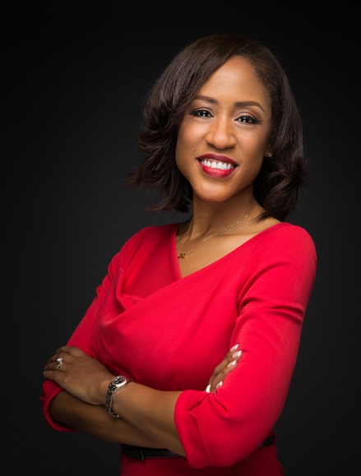 | Name: Angela Chadwick
 | Company Name: Tesla
 | Current or Most Recent Role: Managing Counsel
 | Are You The Top Legal Officer – GC/CLO? No
To whom do you report (Title): Associate General Counsel
Company Revenue and Market Cap:
$21.5 billion revenue, $40.85 billion market cap
Public? Yes
Education:  Harvard Law School, JD  Wharton, Univ. of Pennsylvania, MBA  Univ. of North Carolina, BS, Business  Law School Graduation Date: 1992 | GC Sponsors:  (GCs or former GCs who recommends you as a Ready Now Fortune 1000 GC)  Teri McClure, UPS, former GC, current Chief Human Resources Officer
Contact Information:  AngelaChadwickEsq@gmail.com  678-523-6322  261 Traminer Ct, Fremont, CA 94539 | Primary Area(s) of Practice/Experience (explain):  Global Compliance, Foreign Corrupt Practices Act, Litigation, Alternative Dispute Resolution, Corporate Governance, Privacy, Information Security, Operations Support, Sales Contracts, Technology Agreements, Intellectual Property, Employment Law, Disability Law, Records Management
Any Geographical Preferences or Restrictions?  No restrictions  Preferences: California, Georgia, Florida | Law Firm Experience (firms, years practice areas):  Troutman Sanders, 2 years, commercial litigation
Prior In-House Titles:  Chief Compliance Officer  Managing General Counsel  Deputy General Counsel  Associate General Counsel  Assistant General Counsel  Senior Attorney  Senior Director, Business & Legal Affairs | Industry Experience:  Technology  Manufacturing  Automotive  Entertainment  Real Estate
Size of the Largest Team Managed (explain):
10 attorneys, paralegals and legal assistants
Explain level of Corporate Governance and Corporate Board Room Experience:  10 years of experience as board counsel | In which of these critical areas do you have experience -- M&A, Securities, Corporate Governance, Finance, Litigation Management, Compliance, Regulatory and Enterprise Risk Assessment? Please explain.  Corporate Governance, Litigation Management, Compliance, Regulatory and Enterprise Risk Assessment
Experience with Public Company Securities Issues: | International Experience:  Asia Pacific (most particularly China), Middle East, Europe
Name: Angela Chadwick
Summary of Experience/Bio: (300 words or less)
Angela began her career as a commercial litigation associate at Troutman Sanders, a global law firm servicing business clients from startups to Fortune 500 enterprises. In helping her clients navigate litigation, she developed the desire to help clients avoid disputes by strategically structuring contracts that proactively anticipated potential areas of disagreement.
Transitioning to in-house practice, Angela joined Motown Records as Senior Director of Business and Legal Affairs, where she developed expertise in intellectual property and contracts negotiations. She brought these skills with her to Verizon (then MCI), where she negotiated large-scale technology services agreements as Senior Attorney for Commercial Sales and Emerging Markets.
Angela was recruited to join Atlanta Housing during a period of revolutionary transformation from a traditional housing authority to the nation’s leader in mixed-income, mixed finance real estate development. As Managing General Counsel, she led a team of legal professionals who helped to spur game-changing revitalization and reinvestment in Atlanta.
Angela is currently Managing Counsel at Tesla, where she provides strategic counsel on a wide range of legal and regulatory compliance matters for operations in the United States, China, the Middle East and Europe.

