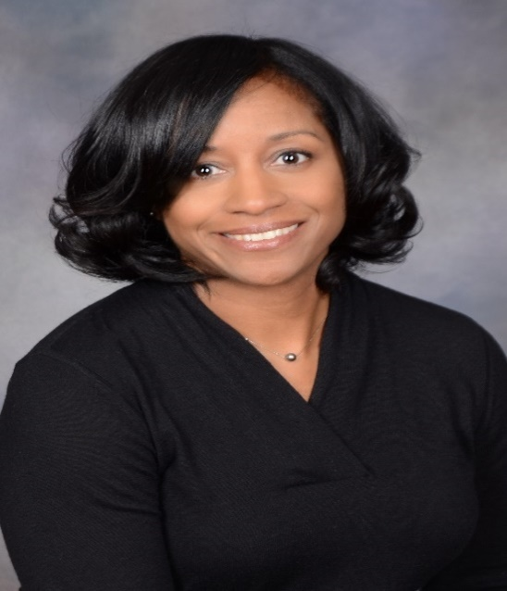 | Name: Andrean R. Horton
 | Company Name: Myers Industries, Inc.
 | Current or Most Recent Role: Executive Vice President, Chief Legal Officer and Secretary
Are You The Top Legal Officer – GC/CLO?
Yes X No
To whom do you report (Title): Chief Executive Officer

Company Revenue and Market Cap: Revenue $567M; Market Cap 633M.

Public? No
Education: University of Michigan – BA, Political Science; Case Western Reserve University – JD. | Primary Area(s) of Practice/Experience (explain): M&A, governance, labor and employment, contracts, international law department management
Law School Graduation Date: 2000 | Law Firm Experience (firms, years practice areas): Calfee Halter & Griswold – Litigation associate – 2 years
GC Sponsors:  (GCs or former GCs who recommends you as a Ready Now Fortune 1000 GC) | Industry Experience: Trucking, specialty chemical, manufacturing
Any Geographical Preferences or Restrictions? | Size of the Largest Team Managed (explain): 8 lawyers (US, EU, Mexico), 4 paralegals (US and EU)
Prior In-House Titles: Executive Vice President, Chief Legal Officer and Secretary (A. Schulman, Inc.); Vice President and Assistant General Counsel; Senior Corporate Counsel; Corporate Counsel | In which of these critical areas do you have experience -- M&A, Securities, Corporate Governance, Finance, Litigation Management, Compliance, Regulatory and Enterprise Risk Assessment? Please explain.  - M&A – Led legal team during bid process and sale of publicly traded company for $2.2B. Managed due diligence, regulatory compliance, merger agreement drafting and legal integration post-acquisition. Negotiated and managed the acquisition of companies ranging in size from $30M to $800M, leading internal teams, outside counsel and consultants with respect to due diligence, contract terms and integration.  - Governance – Managed procedures regarding policies (e.g., Code of Conduct and related reporting systems), board of director annual processes, and NYSE listing requirements. Directly support chair of nominating and governance committee.  - Litigation Management – Managed international litigation portfolio, including legacy asbestos docket.  - Compliance - Deployed global entity management and global third-party compliance databases.  - Regulatory – Managed procedures for GDPR, FCPA, government contracting, export compliance, conflicts minerals, REACH, and the California Transparency in Supply Chain Act.
Contact Information: andreanrhorton@yahoo.com
330.354.1811
2364 Delamere Drive
Cleveland Heights, OH 44106

Explain level of Corporate Governance and Corporate Board Room Experience:
Experience with Public Company Securities Issues: Served as CLO for NASDAQ and NYSE listed companies. | International Experience: Served as CLO of publicly traded company with 54 locations in US, Latin America, EMEA and APAC.
Summary of Experience/Bio: (300 words or less)
Andrean Horton is Executive Vice President, Chief Legal Officer and Secretary for Myers Industries, Inc., a diversified, international plastics manufacturer of returnable packaging, storage and safety products and specialty molding. Myers is also the largest tire repair supply distributor in the United States. In her role, Ms. Horton is responsible for overseeing the legal affairs of the Company and serving as secretary to the Board of Directors. Ms. Horton provides counsel on a wide range of legal issues, including mergers and acquisitions, intellectual property, real estate, contracts, labor and employment, compliance and litigation.

Prior to her current position, Ms. Horton served as Executive Vice President, Chief Legal Officer and Secretary for A. Schulman, Inc., a leading international supplier of custom compounds, masterbatches and resins and served in this capacity during LyondellBasell’s acquisition of A. Schulman for $2.25B. Ms. Horton also served as General Counsel for the Bartech Group, one of the country’s largest minority-owned talent acquisition and management firms, and served in a variety of capacities for YRC Worldwide Incorporated, one of the largest transportation service providers in the world, including Vice President of Legal and Regulatory, Vice President and Assistant General Counsel for Roadway Express and Corporate Counsel, focusing on labor and employment law. Ms. Horton began her legal career as an associate at Calfee, Halter & Griswold, LLP and her other law firm experience includes her association with Cooper and Walinski, LPA.

Ms. Horton is a member of the Board of Directors of the Ohio Bar Liability Insurance Company, a for-profit subsidiary of the Ohio State Bar Association providing professional liability insurance to attorneys throughout the state.

